Lab Assignment-1
Creation and Insertion in Banking Database.
Database Description: A banking system maintains information about branches, customers, accounts, loans, and transactions. In this assignment, students will create tables and insert sample records. Objective: To understand basic SQL commands for table creation (CREATE) and data insertion (INSERT) without using database constraints.
- Create the following tables with their respective columns, data types and size:
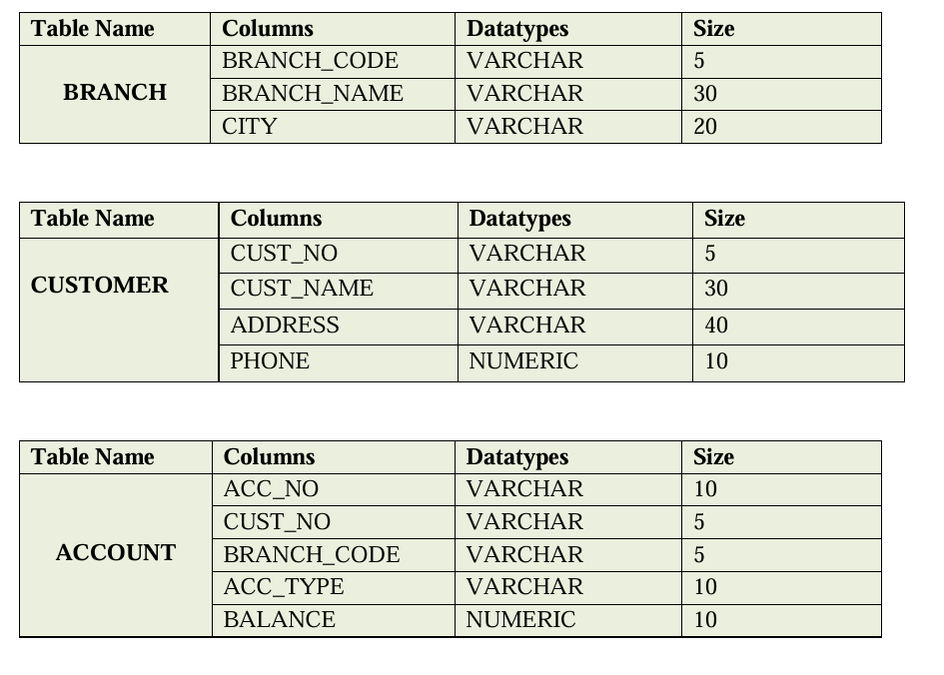
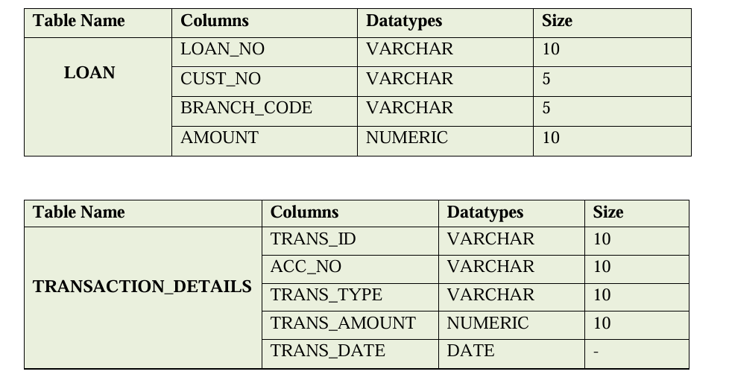

Solution :-
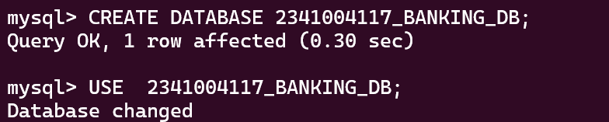
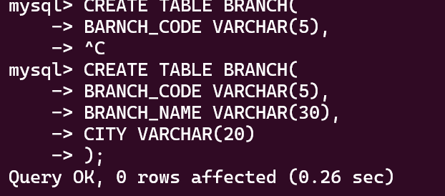
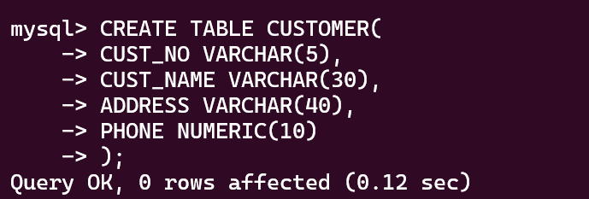
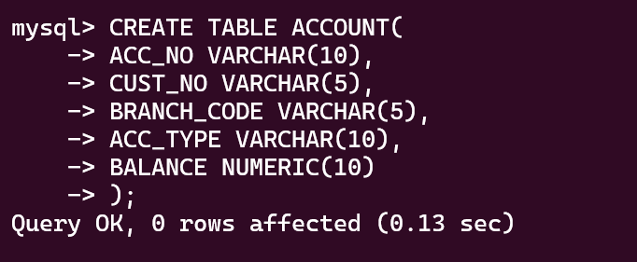
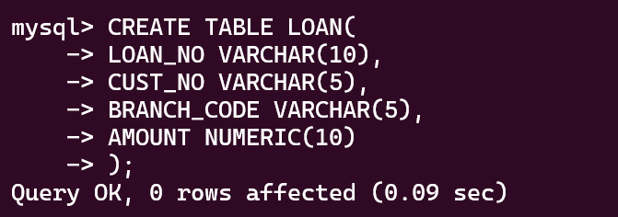
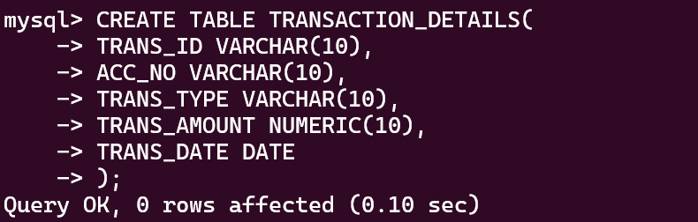
- Insert data into Branch table with the given data.
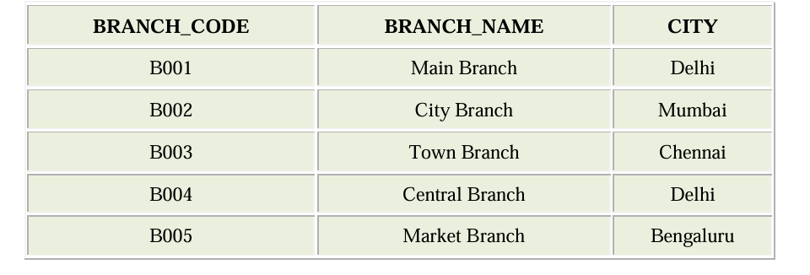
Solution:-
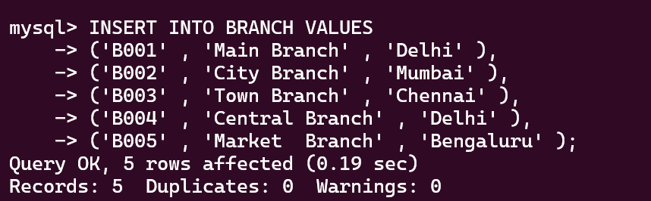
- Insert data into Customer table with the given data.
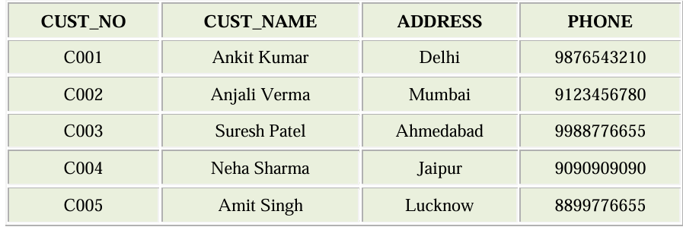
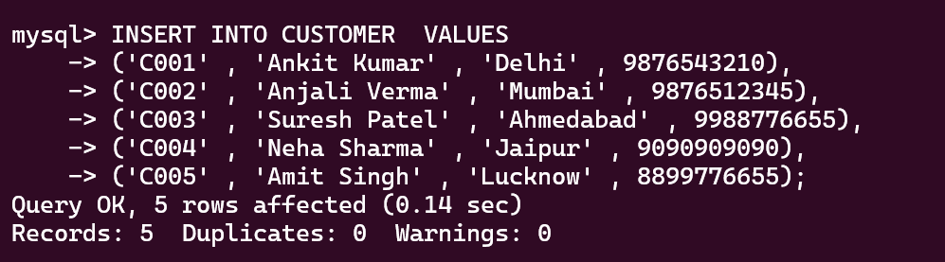
- Insert data into Account table with the given data.
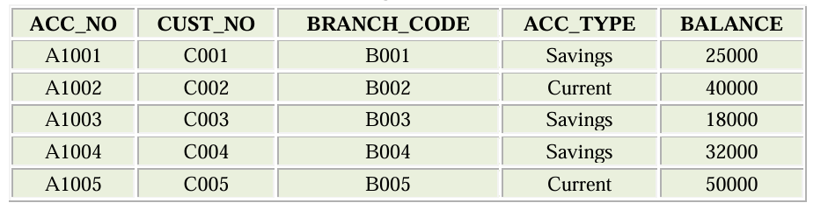
Solution:-
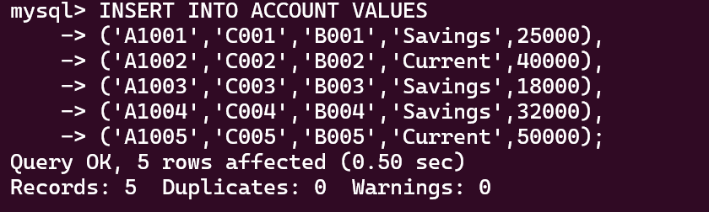
- Insert data into Loan table with the given data.
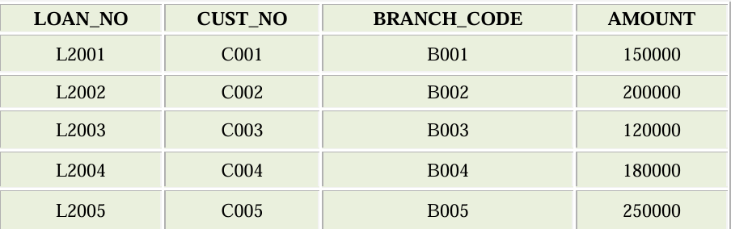

Solution:-
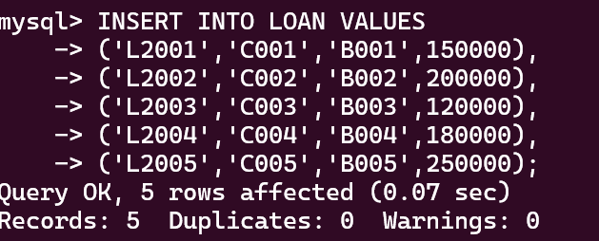
- Insert data into Transaction Details table with the given data.
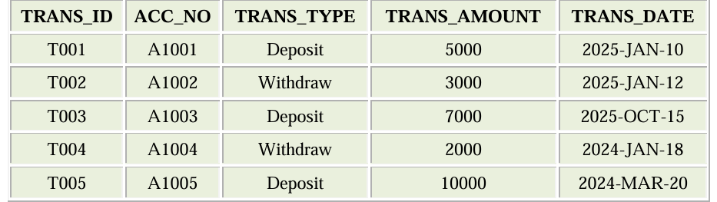
Solution:-
